Record No: 0660
WILLIAM ARTHUR TENISON BELLINGHAM SOMERVILLE (“Bunt”)
of Clermont, Rathnew, Co Wicklow and Reendesert Lodge, Bantry, Co Cork

Eldest Son of Bellingham Arthur Somerville (0631) by his wife Margaret Hall Clinch (0632) daughter of William Clinch (0633) by his wife Rachel Hall Wright..

Birth: 8 Aug 1882, at Francis St, Newtownards Co Down
Bapt: 27 May 1883, at St Audoen’s Church, Dublin
Marriage: 27 Jan 1925, at St Andrew’s Church, Westminster, London to Amy Kathleen, widow of
Alan Ferguson, 2nd dau of Gen Standish Henry Harrison of Castle Harrison, by his wife
Amy Georgiana, daughter of Major General G F de Berry
Death: 13 Feb 1951, at Reendesert Lodge, Bantry. Bd 15 February at The Old Abbey
Cemetery, Bantry

.
Lt Col The King’s Own (Royal Lancaster) Regiment
Lt Col 1ST Batt, The Loyal Regt.
Served in World War1 in France. 1914 – 1918
DSO & Bar
Brevet Lt Col. Mentioned in despatches
Attached Machine Gun Corps
Commanded MGC School at Ahmadnagar in India

d.s.p

Source: Somerville Index

Further research:
1891 Census: With his family Witney, Oxfordshire
1901 Census: Student at Sandhurst, Gentleman Cadet

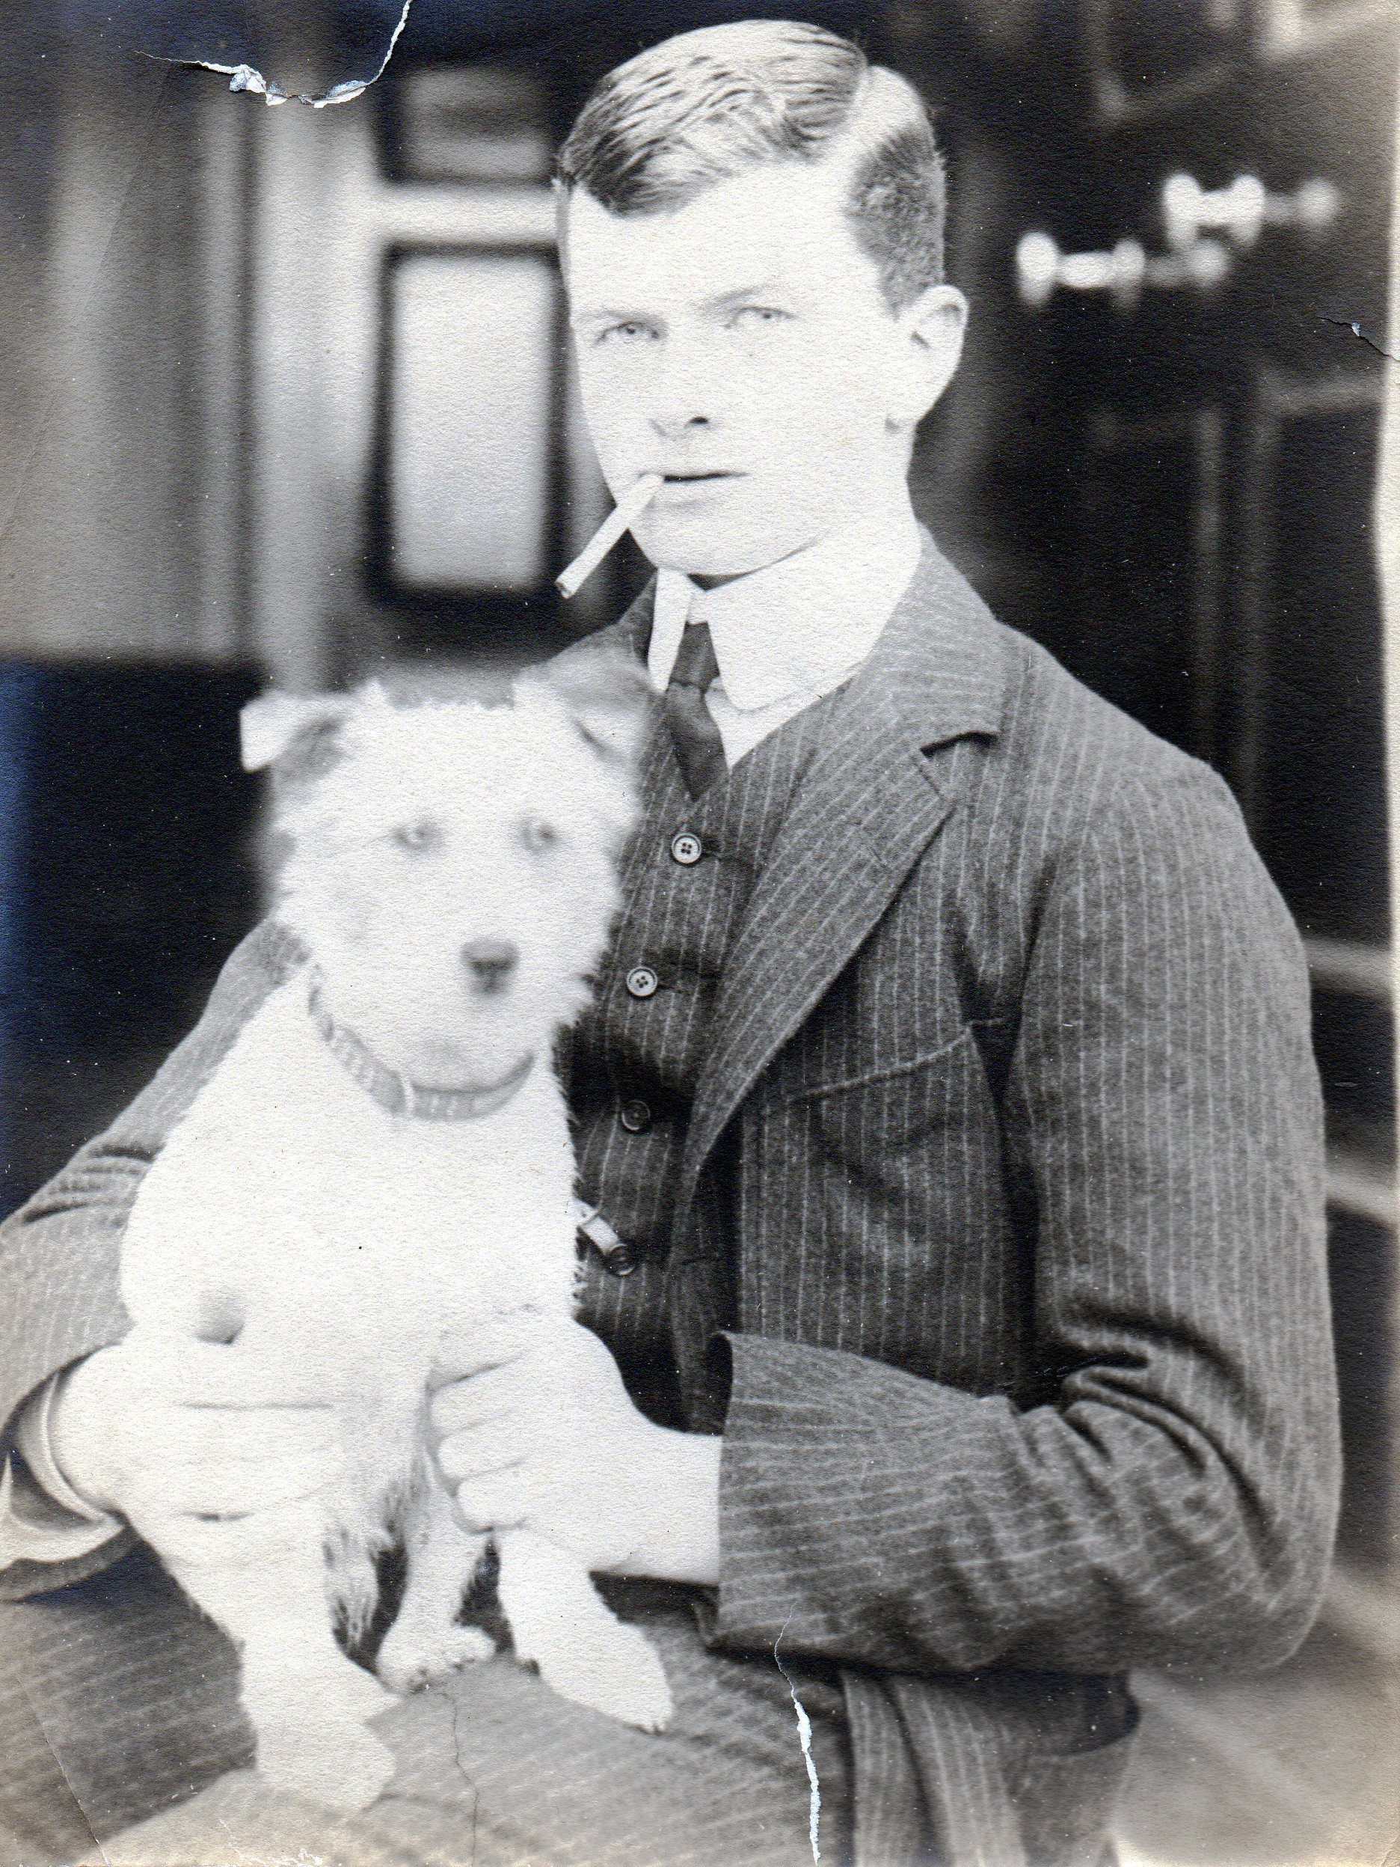

Captain William A. T. B. Somerville,D.S.O., The King's Own (Royal Lancaster Regiment),
The London Gazette, 27 August, 1915.

vice Captain W. A.T. B. Somerville, D.S.O., The King's Own (Royal Lancaster Regiment).- Dated 29th January, 1916.
Supplement to London Gazette, 24 February, 1916.

Maj. (A./Lt.-Col.) William Arthur TenuisonBellingham Somerville, D.S.O., R.Lan. R.
(D.S.O. gazetted 18th February, 1915.) BAR TO DISTINGUISHED SERVICE ORDER.
Third Supplement to London Gazette of 23 Nov 1917

Maj. (A./Lt.-Col.) William Arthur Tennison Bellingham Somerville, D.S.O., R. Lan.R.
For conspicuous gallantry and devotion toduty in handling his battalion during two attacks. It was largely owing to his courage
and ability that a defensive flank was successfully formed on both occasions. His conduct was beyond all praise.
Supplement to London Gazette, 6 April, 1918.

http://www.london-gazette.co.uk/issues/30399/supplements/12315

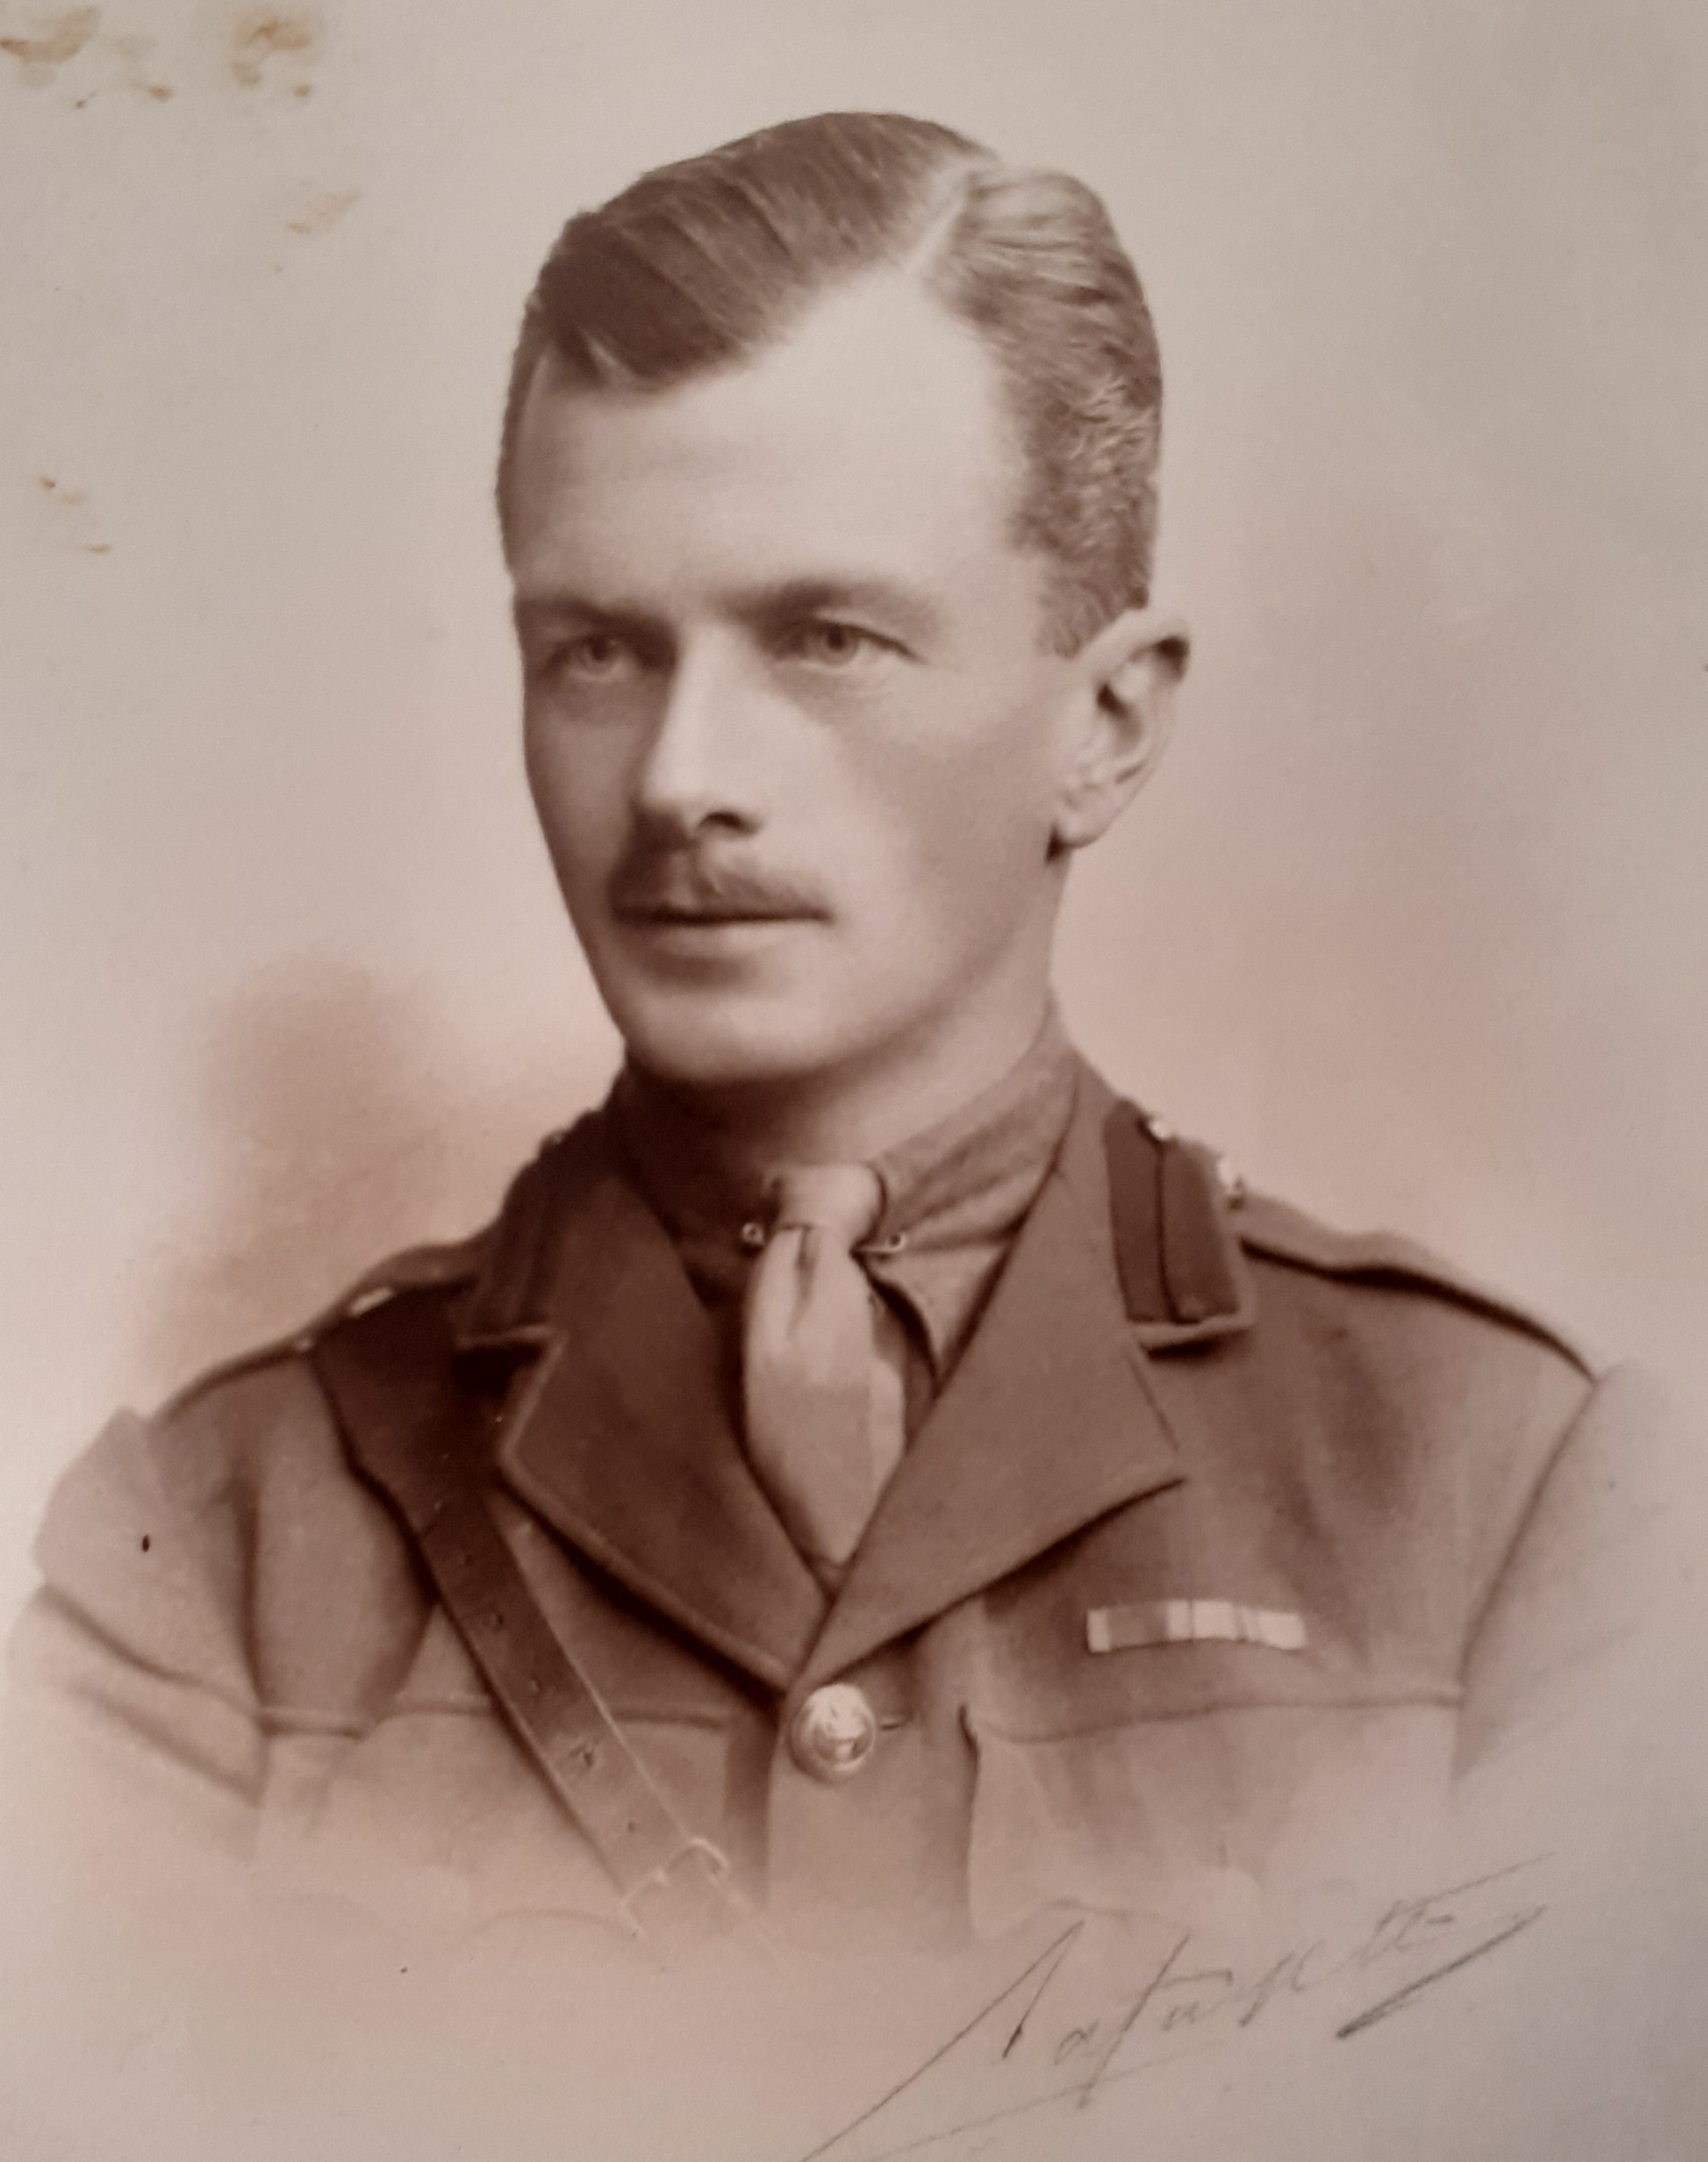

Who was Who:

SOMERVILLE, Lt-Col William Arthur Tennison Bellingham
DSO 1915
Born 8 Aug. 1882; s of late Bellingham Arthur Somerville and Margaret, y d of late William Clinch; m 1925, Amy Kathleen, widow of Alan Campbell Ferguson and d of General Standish Harrison, Castle Harrison, Charleville, Co. Cork; died 13 Feb. 1951
late the King’s Own Royal Regiment (Lancaster)

Career
Entered Army, 1901; Captain, 1913; Major, 1916; European War, 1914–18; N. Russia, 1919 (despatches nine times, DSO and bar, Bt Lt-Col); commanding 1st Batt. Loyal Regt, 1927–28; retired pay, 1928

Club
Junior United Service

Address
Clermont, Rathnew, Co. Wicklow
‘SOMERVILLE, Lt-Col William Arthur Tennison Bellingham’, Who Was Who, A & C Black, 1920–2008; online edn, Oxford University Press, Dec 2007 [http://www.ukwhoswho.com/view/article/oupww/whowaswho/U243165, accessed 12 July 2011]
NORTH RUSSIA 1919
Late in 1919 Britain sent troops to Murmansk and Archangel in northern Russia. They were part of an international force designed to protect Allied interests there during the Russian Civil War, and to offer assistance to those Russian forces fighting the Bolsheviks in that conflict.
8th Battalion Machine Gun Corps was based at Dibgate, Shorncliffe on the 30th March 1919 and was formed into “A” Foreign Service Battalion MGC, from the cadre of the 8th Battalion MGC, from France. Training commenced. Designation of the unit changed to the 8th (special) Battalion MGC, under the command of Lt. Col. W A T B Somerville DSO (Royal Artillery) from 12th April 1919. The Battalion was stationed at Crowborough Camp, Sussex on the 15th April, and on the 7th May was warned for North Russia.
On the 12th May, the Battalion entrained for Newcastle upon Tyne, via London. The Battalion boarded HMT Zyarietza the next day, and was given a good send off, all ship yard work ceased temporarily and all steamers on the Tyne blew their hooters.
Arrived in Murmansk on 20th May and on the 24th May, sailed with convoy and icebreakers for Archangel. Arrived in Archangel- Smolny Barracks, on 26th May 1919. On the 27th May marched to Sobornaia Wharf. On the 9th June embarked on Ferryboat and proceeded up the Dwina (River).
http://www.cairogang.com/murdered-men/angliss/russia/8bn-mgc.html

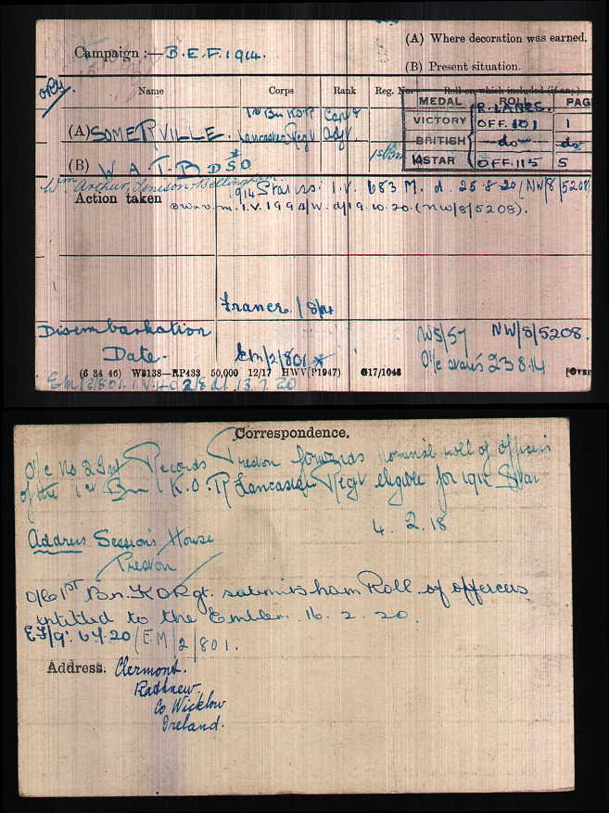

Bunt was a keen sportsman in India (and fisherman at home). He brought home many trophies, including the then record GUR head which hangs (2007) in Reendesert. Many of his heads were donated to the Natural History museum in Dublin.

He improved the gardens at Reendesert with the assistance of Jamsie, the gardener.. There was a particularly fine water garden.

For many years, he was a director of Clinch & Co of Witney, but he would not have been described as a businessman. He, with Jim, was one of his mother’s executors. It was alledged that their inexperience of the business world lead to the substantial dilution of family control of the Brewery by the sale of shares to Mr Lowe, the Manager. The administration of his mother’s estate lead to enormous dissension among the family, particularly between Bunt and Tetty; but members of the family kept taking ‘sides’ for many years, even after Bunt’s death.

Regi always referred to him as being conscious of his position as eldest son. He evidently did not like being seen carrying parcels. He was quiet and somewhat retiring. He was inclined to procrastinate; as a result, he didn’t ‘put his affairs in order’ after his mother’s death in 1949. He was a heavy smoker and ultimately succumbed to lung cancer.

WBRBS from personal knowledge and conversation with Regi

